
Data Governance and Quality Framework

2025
Version 1.3

Contents
Contents 1
Purpose 3
Introduction 3
Scope 4
Data Governance & Quality Framework 5
Data Principles and Quality Dimensions 6
Data Principles 6
Data Quality Principles 8
Data Quality Dimensions 10
Organisation 11
Data Governance Function 12
Data Quality Capability 13
The Importance of People in Data Quality Management 14
People – Roles & Responsibilities 15
Data Governance and Quality 16
Data Governance and Quality Manager 16
Data Governance Function Members - Data Governance Analysts 17
Data Quality Function Members – Data Quality Analysts 17
Data Owners 18
Data Stewards 19
Data Custodians 19
Report Owner 20
Control Owner 20
Control Operator 20
Processes 21
Data Quality Management Process (DQMP) 22
Control Model 23
Policies 24
Operational (Run-time) Data Quality Controls 26
Data Governance Technology Enablers 28
Data Quality Technology Enablers 30
Data Profiling & Data Quality Scoring 30
Inspection and Monitoring 30
Data Risks 31
Monitoring 33
Data Governance Monitoring 33
Data Quality Monitoring 34
Reporting 34
Communications 35
Audiences 35
Communications Channels 35
Change Management 36
Appendix I - Definition of Terms 37
Appendix II - Data Domains 41
Appendix III – Definition of Materiality 42
Appendix IV: Dimensions of Data 44
Appendix IV - Document Control 48

Document Properties
Document | Data Governance and Quality Framework
Owner | Data Governance Forum
Department | Data
by
Review History
This document has been reviewed by the following:
Version | Reviewed by | Date
1 | Data Governance and Quality Team | 02/2023
1.1 | Data Governance and Quality Team | 06/2024
1.2 | Data Governance and Quality Team | 06/2024
1.3 | Data Governance & Quality Manager | 06/2025

Approval History
This document has been approved by the following:
Version | Approved by | Date | Next Review
 | Chief Data Officer | 20/03/2023 | 20/03/2024
 | Data Governance Forum (review only) | 03/2023 | 03/2024
 | Data Governance Forum (review only) | 07/2024 | 06/2025

Amendments
Version | Amendments(s) | Date Published
0.1 | Creation | 22/02/23
1.0 | Following review and approval from CDO | 20/03/2023
1.1 | Updated following Compliance review | 11/04/2023
1.2 | Moved into new document template. Minor updates. | 19/06/2024
1.3 | Moved the document control at the start of the document | 06/2025

Purpose
The purpose of this framework is to describe Canopius’ approach to Data Governance and Quality Management, outlining the policies and standards which form the control model. It ensures that Canopius and its external partners manage data efficiently, purposefully and in accordance with regulations.

Introduction
Data is increasingly regarded as an organisational asset. It is fundamental to effective, data-driven decision-making and underpins everything from routine operational processes to strategic business direction. To support this statement, it is necessary to provide clarity on the importance of how we manage data.
When operating in a highly regulated business sector, it is insufficient to simply store and use data as a component of our business processes. It becomes necessary to:

- Define the data sufficiently,
- Have accurate data,
- Use it in a controlled manner, and
- Be allowed to use the data for its intended purpose.
Only by doing this can we ensure that good data practices are repeatable, and data is of a sufficient quality.

This framework provides a structured approach to understanding, documenting, and improving the quality of data through work that is proactive, evidence-based, and targeted. All Canopius employees should understand why data quality is important and feel able to proactively identify and address data quality issues. The orchestration of a high level of data quality is the main objective of the implementation and operation of Data Governance.

The framework is relevant to anyone, whether creating data, or working directly or indirectly with it in business processes and producing data-informed insights Senior leaders should be advocates for the framework and should encourage staff to adopt the practices in their roles. All members of Canopius should familiarise themselves with the data quality principles and, where relevant, apply them in their context.

Scope
The agreed scope of Data Governance within Canopius is:
- Enterprise Business Operations: UK, US, APAC, and Bermuda.
- All applicable legal and regulatory environments.
- All data captured / processed / stored / accessed / used by the business.
- Structures / People / Processes / Technology / Controls required to ensure practical and effective governance of data; and
- Capabilities / People / Processes / Technology / Controls required to deliver, manage, and maintain a high-quality data estate.

While the above definition of scope is inclusive for many aspects of Data Governance, we must identify and prioritise Key Data Elements that support:
- Material data items in the models (please refer to Appendix III for a definition of Materiality/Material data items).
- Compliance to data related regulation such as GDPR (PII data), Lloyd’s Principles, Consumer Duty, and Solvency II and IFRS 17.
Key business processes such as Exposure Management, Reserving and Business Planning.

Data Governance & Quality Framework
This document explains how Canopius governs data by describing our approach to the implementation and ongoing operation and management of Data Governance. The following sections covers:
- Data Principles – The foundation for principle-based data governance
- Organisation – Formal governance structures/bodies
- People, roles, and responsibilities
- Process - Data Governance outline process model.
- Controls – Policies, Minimum Standards and Procedures
- Technology – Tools to support data governance and quality management.
- Monitoring and Reporting
- Communications
- Data Quality as a Capability
- Definition of Terms
- Appendices – Reference materials

Appendix I contains the Definition of Terms which are commonly used throughout this document.

Data Principles and Quality Dimensions

Data Principles
The governance of data is principle based. The Data Principles are high-level rules which guide the governance of data and its quality management. These principles form the basis of the Group Data Policy which is a key deliverable from the design of the Data Governance Control Model. The data principles are high-level rules, which are used to guide the governance of data and quality management. These principles are described in the table below.

Ref. | Principle Description
1 | Data is an asset - Data should be treated like any other asset and consequently should be tracked and managed through its lifecycle.
2 | Data has value - Data as an asset has value, which builds into intellectual capital. Its value should be understood to enable effective management, not least the risk of loss, corruption or release and associated costs.
3 | Data is owned - All data has an owner, assigned by role, who is accountable for the data adhering to the other principles.
4 | Data is standards based - Data should be designed, built, held, accessed, used, and disposed of through the application of agreed standards to ensure quality, consistency, security, and compliance to all necessary legal and regulatory requirements.
5 | Data is consistent - Data should be held consistently through use of appropriate modelling techniques and application of dedicated data components to support the purpose for which the data is to be used.
6 | Data Quality must be sufficient for its use case and managed - Data must be trusted, accurate and fit for purpose for operational and analytical use cases.
7 | Multiple formats should be supported - Data architectures should be capable, where appropriate, of supporting structured, semi and unstructured data, as well as being capable of ingesting data in a variety of formats from sources.
8 | Data should be accessible on a controlled basis - Data access should be controlled, based on the type of data and the roles that users perform and all access should be auditable.
9 | Data must be capable of being shared internally (where authorised to do so) - Shared data maximises reuse and is cost effective whilst maintaining security and data integrity centrally.
10 | Data must be understood – Catalogued data enables it to be understood and used for its intended purpose, minimising the risk of misinterpretation and maximising consistency.
11 | Data should be secure - Securing data correctly minimises the risk of exposure through misuse or accidental loss and ensures legal and ethical commitments are met.
12 | Data is scalable - The data technology and capabilities should be able to grow sustainably as data volumes, velocity, and demand increase.
13 | Reuse rather than rebuild - The ability to reuse data, processes and technology should always be considered when building new capabilities. Duplication of processing should be minimised or eliminated. Data duplication should only be present when there are significant benefits to its duplication, e.g. performance or purpose.
14 | Data should be auditable and traceable - Data access, use, capture, processing, storage, and deletion should be auditable. Data flows through the organisation should be traceable.
15 | Data should comply with all legal and regulatory requirements - All legal and regulatory requirements should be complied with to eliminate financial and reputation risk from non-compliance.
16 | Data is managed in line with ethical standards - Ethics are principles of behaviour based on the idea of right and wrong. They focus on fairness, respect, responsibility, integrity, quality, reliability, transparency, and trust. Unethical data handling can result in the loss of reputation and customers, and in some cases can lead to legal prosecution.

Each of the principles are used in defining how data is managed. For example, “10. Data must be understood” infers that data must be defined in sufficient detail to prevent ambiguity or assumption around its purpose, uses, structure, source location and ownership.

Data Quality Principles
Data Quality has its own set of principles in addition to the Data Principles listed above, which define a framework of management arrangements that assure data consumers, customers, partners, and other stakeholders that the quality of Canopius’ data is reliable and sustainable. These principles must permeate throughout the Data Quality Management System that supports this Framework.

Canopius has adopted the following principles to assure the quality of its data, supported by appropriate policies, procedures, guidance, and training.

Data Quality Principles
01 | Data is an asset: Data is seen and treated as any other asset by the Organisation. The quality of the data serves as the main utility indicator of the asset and hence dictates its (economic) business value.
02 | Criticality: Data Quality focuses on the data most critical to the enterprise and its customers. Priorities for improvement are based on the criticality of the data and on the level of risk we are exposed to if data is not correct.
03 | Lifecycle management: The quality of data is managed through the data lifecycle, from creation or procurement through to disposal.
04 | Prevention over correction: Data Quality is focused on preventing data errors and conditions that reduce the usability of data (root cause); it must not be focused on simply correcting records after the fact. Root causes are often related to process or system design, and improving data quality often requires changes to processes and the systems that support them.
05 | Standards-driven: All stakeholders in the data lifecycle have data quality requirements. To the degree possible, these requirements should be defined in the form of data standards and expectations against which the quality of data can be measured.
06 | Governance: Data Governance activities must support the development of high-quality data and Data Quality activities must support and sustain a governed data environment.
07 | Measurement: Data quality levels needs to be measured and monitored objectively and consistently. Measurements and measurement methodology should be shared with stakeholders since they are the arbiters of quality.
08 | Embedded in business processes: Business process owners and Business Data Owners are responsible for the quality of data produced through their processes. They must enforce data quality standards in their processes.
09 | Systematically enforced: System owners must systematically enforce data quality requirements, with support from the Data Governance process.
10 | Connected to service levels: Data quality reporting and issue management should be incorporated into Service Level Agreements (SLA).
11 | Canopius’ Data Quality Management capability is enterprise wide: Data Quality should be considered at each phase of the data lifecycle to ensure data is trusted and reliable, ensuring transformations or actors do not introduce errors downstream. This means that the scope of the data extends even beyond the enterprise borders into the extended enterprise, as data sources might be residing elsewhere.
12 | Universal Responsibility: Everyone who produces, processes, uses or supports the capture, management, and exploitation of data in Canopius has responsibility for the quality of the data.

Data Quality Dimensions
Data Quality dimensions are used to define the characteristics of data which need to be achieved and are a useful measurement approach for comparing data quality levels across different systems (or tables or business functions) over time. Each of the core characteristics shared across all data are covered in the table below.

Their respective use and the extent to which they need to be monitored and improved upon for each data set depends on the criticality of the data and the associated risks, including their likelihood to occur and their envisaged impact. It is important to note that the cause of data quality issues within any of these dimensions may be related to people, process, technology, or a combination of these.

Whilst the dimensions listed below are important to the quality management of data, not all are applicable to all data and not all are possible to be mandatory. The mandatory dimensions required to implement prudential data are indicated in the table below.

Data Quality Dimensions | Mandatory to implement
- Accessibility
- Accuracy (including currency) | X
- Clarity
- Completeness (Coverage; Existence) | X
- Consistency | X
- Integrity
- Objectivity
- Plausibility (Believability)
- Precision
- Privacy
- Relevancy
- Reliability
- Timeliness | X
- Uniqueness | X
- Usability
- Validity (Correctness) | X
- Standards Based (Conformity) | X

Descriptions of these mandatory dimensions can be found in Appendix IV.

Organisation
The combination of Governance structures, people and processes provide accountability for data by defining responsibilities for the management and control of the data assets.

The formal governance structures include:
- The Data Governance Forum (DGF)
- Data Working Groups (DWG)
- The Data Governance Function (DG Function), and
- The Data Quality Team (DQT)

The DGF comprises of Managing Data Owners who provide strategic direction and oversight of the governance of data across the Canopius Group. DGF is the body to which issues can be escalated and from which support and direction is provided.

The DGF is supported by Data Working Groups where appropriate, to investigate and make recommendations on areas such as remediation of data quality issues, definition of business metadata, definition / amendments to standards and guidelines and continuous improvement of processes. The Governance structure is illustrated below:

Data Working Groups
Data Governance Forum
GLT
(GCEO)
Group Leadership Team

Operations Management Forum
Group COO

The Data Governance Forum reports into the Operational Management Forum with matters escalated to Regional / Group Committees as required to ensure that Data Governance initiatives are supported and implemented within each Region.

Data Governance Function
The DG Function comprises:
- The expertise to develop, review and maintain policies and standards; support and facilitate Data Working Groups.
- Support projects and BAU fixes in meeting policy and standards requirements and in reviewing designs, providing oversight to build and support testing.
- Monitor and report on Data Governance activity through Governance metrics via a Data Governance scorecard; and,
- Administer, support, populate, refresh, curate, maintain and facilitate publication of the metadata toolset that supports Data Governance.

The DG Function collaborates with stakeholders across the organisation to deliver the required capability. Stakeholders have varying levels of accountability and responsibility for specific aspects of Governance, including:

- Risk Management – defining risk appetite around data quality / business process.
- Data Protection and Compliance – supporting compliance to legal and regulatory requirements through identification and understanding of data, by its characteristics, enabling understanding of its flows, levels of quality and links between data and processes.
- Data Owners and Stewards who have accountabilities and responsibilities for the data under their remit, to ensure it is fit for purpose or action is undertaken to remediate where it falls short.
- Data Quality Management – supporting the achievement of the DG goals through the management and improvement of Data Quality via controls, processes, and monitoring of data.
- Data Management / IT – establishing and operating the required metadata architectures, embedding DG by design in data-based solutions, monitoring and managing data processes, reporting, and remediating issues.
- Change Management - in respect of change methodologies and data governance by design.
- Data producers and consumers – defining “fit for purpose” for their needs, reporting issues, adopting and meeting the standards required, and enabling understanding of the data they produce and use so that it can be trusted in the knowledge of where it comes from / goes to and what happens to it on its journey.
- Data Custodians - ensuring safe custody, transport, storage of the data and implementation of business rules.
- Information Security - liaise and collaborate.

The DG Function has a direct relationship with:
- The Data Governance Forum.
- Data Working Groups.
- Regional EXCO Members.
- DPO and Data Privacy office.
- Change Management Boards / Committees.
- Data Owners and Stewards.
- IT Support for the Data Governance Toolset.

Data Quality Capability
The objectives of the Data Quality capability and its Data Quality Management System (DQMS) are to:

- Enable Canopius to raise the quality of its data estate from point of entry to point of end use / exit to required levels determined by the Data Owners.
- Define the organisational structures, guiding principles, people, processes, technology, and controls that are required.
- Define the dimensions against which data quality is assessed.
- Ensure compliance to regulatory obligations.
- Ensure confidence in key decisions are based upon reliable data and models; and
- Establish the capability required to manage Data Quality across the Group.

The Importance of People in Data Quality Management
Data Quality Management (DQM) extends beyond Governance and involves all stakeholders in data, from users and producers to custodians in data management. DQM is primarily a people-based activity supported by effective processes facilitated by use of appropriate tools.

- The Data Governance Forum provides oversight, direction, and budget to Data Quality Management. Forum members monitor adherence to the Group Data Policy and provides remedial steps and/or necessary escalations for violations. Forum sets the strategic guidance on Data Governance and Quality Management, including how to put into action and oversee the framework.
- The Data Quality Team formalises the DQM System(s), undertakes root cause analysis and solution definition of data quality issues in collaboration with Data Owners.
- Data Owners are accountable for the quality of data and evidence this accountability through an annual attestation of quality and control on their data.
- Data Stewards are responsible for the monitoring of data quality, raising issues, providing business knowledge for impact analysis and input to remediation options.
- Data Custodians are responsible for the application of remediation requests and for raising issues identified through the operation of data management processes.
- Data Architecture has a key role in Data Quality Management in establishing, managing, and ensuring compliance of conceptual, logical, and physical data models through which consistency of design and definition is enabled.

People – Roles & Responsibilities
Outside of the DG Function and DQT, the following roles are recognised:
- Group-level Accountable Data Owners who provide sponsorship and have ultimate accountability for Data Governance / DQM
- Data Owners who have accountability for data governance within their domain
- Data Stewards who have responsibility for a data set; several data stewards may support a Data Owner
- Regional EXCO Members who have accountability for ensuring that data within each region adheres to agreed standards and that data governance initiatives are sponsored and implemented within each region.
- Data Custodians – Those involved in Data Engineering and Architecture, Information Security, Risk, Compliance and Audit
- Data Producers - Those responsible for input of data such as Underwriters, Operations central services, third parties and Claims Administrators
- Data Consumers - Those using the data – Underwriters / Claims managers in operational course of business, MI / BI users, etc​.
- Project Managers
- Data Management and Data Solution Architects – Those responsible for design, build and operation of data processes, flows and enabling technology​.
- Report Owners – those responsible for the definition, standards, and usage of key business reports.
- Control Owners – those responsible for the implementation and supervision of control checkpoints within a process or system.
- Control Operator - those accountable for ensuring that key data controls are effective and are maintained.
To deliver the required metadata capability, the DG function must also have appropriate access to technical SMEs for given data sets and processes, and to data architecture resources in terms of data design.

Data Governance and Quality
Although tightly linked, Data Governance and Data Quality are treated as separate functions under common management.
The DG Function and DQT roles include:

- A Data Governance and Quality Manager – with overall responsibility for Data Governance and Data Quality.
- One or more Data Governance Analysts.
- One or more Data Quality Analysts; and
- If required, Metadata analysts supporting the Data Governance Toolset.

Resource numbers are reflective of workloads, size and scale of activity as the Data Governance Plan is implemented and requirements/practices evolve.

Data Governance and Quality Manager
Role:
A full-time role split between Data Governance and Data Quality responsibilities.

Key Responsibilities:
- Development of a data culture and of a data quality management capability which supports the Group Data Policy across Canopius.
- Secretary of the Data Governance Forum.
- Chair of Key Data Working Groups.
- Custodian of data control framework and attestation process.
- Owner of Data Governance Toolset, with responsibility for its compliance to all Canopius’ Policies and standards, its population and maintenance of metadata to agreed standards.
- People Management with regards to the DG Function and DQT.

Data Governance Function Members - Data Governance Analysts
Role:
Full time responsibility within the DG Function to develop a data-led culture across Canopius. Assists in the establishment and operation of data governance structures and processes, the definition, implementation and operation of Data Policies and standards, and implementation of metadata tools that capture and publish metadata supporting the Governance of Data.

Key Responsibilities:
- Member of Data Working Group(s) with specific responsibility for an area of Governance e.g. Data Quality, Governance monitoring, waiver management, etc.
- Chair of nominated Data Working Groups.
- SME providing support and advice as required to the business, and stakeholders with defined data roles.
- Acting as Administrator for Data Governance metadata tools ensuring configuration and timely population, supporting the collation and agreement of metadata, and supporting the ongoing maintenance with Data Stewards.
- Being part of the project team delivering the roadmap for Data Governance; and supporting the management of the Data Risk Register and Data Quality Incident Logs in accordance with the Canopius Risk Management Framework and supporting processes.

Data Quality Function Members – Data Quality Analysts
Role:
Full time responsibility within the Data Quality team to develop a high-quality, data-led culture across Canopius. Assists in the establishment and operation of data quality management systems and processes, the definition, implementation and operation of Data Quality standards, and implementation of DQ tools.

Responsibilities:
- Member of Data Quality Working Group(s).
- SME providing support and advice as required to the business and stakeholders with defined data roles.
- Acting as an administrator for DQ Tools, configuring and operating the tool to support data profiling and data quality analysis and monitoring.
- Supports the DG Function in the capture and maintenance of metadata associated with Data Quality business rules in the Data Governance Toolset.
- Supports the management of the Data Risk Register and Data Quality Incident Logs in accordance with the Canopius Risk Management Framework and supporting processes.

Data Owners
Data in Canopius is “owned” by the enterprise, but accountability for that data in terms of quality and adherence to Group Data Policy must be assigned to roles in the organisation, and individuals fill these roles. Therefore, “Data Owners” to fulfil those accountabilities are designated from business groups rather than technical areas.

Ownership of the data asset must reside at the highest level possible within the organisation.
The Group-level Accountable Data Owners are already members of the Risk Committee and the Canopius Leadership Team (CLT) and have the ultimate accountability for Canopius’ data.
Managing Data Owners are responsible for the governance of the data within their respective data domains and ensure that the governance is in place (compliant with policies, procedures, and controls). They are core members of the Data Governance oversight body - the Data Governance Forum.

The approach to identification of Data Owners involves definition of logical Domains of Data, such as, Policy, Claims, Finance, etc., then identifying the Accountable and Managing Data Owners for each Domain (or Sub-domain according to the existing level of control for the data). Managing Data Owners identify Data Stewards with appropriate knowledge and experience of the data in the data domains and sub-domains.
Note: Data is not restricted by region and the ownership is global for a given data domain. Stewards are identified within regions as well as by sub-domains, etc.

Regional EXCO Members, while not part of the formal Data Governance function are accountable for the business within each region. This naturally entails accountability for the business functions, business processes and the business data that is created within each region. They therefore take a key role in ensuring that Data Governance is implemented within each region and that data created within each region adheres to Data Governance policies, standards and procedures. As budget and resource holders, Regional EXCO Members will be responsible for ensuring the required resourcing and sponsorship is in place within each region to ensure delivery of Data Governance initiatives. Regional EXCO Members will work closely with Data Owners for their domain to ensure implementation activities are progressed.
Role:
The Data Owner role is one of ownership and therefore accountability, providing oversight and direction. The responsibility for undertaking that direction and the actions that support it lies with Data Stewards who support the Owners. The scope of data ownership of a data domain is global and includes external data used by Canopius (for example, claims data from MGAs, Bordereaux data from Coverholders, data from third party services).

Data Owners execute their role primarily through membership of the Data Governance Forum and working with the Data Governance Function / Data Quality Management Team. As members of the Data Governance Forum, Data Owners, working through the DG Function / DQT, can initiate and direct Data Working Groups to support them in performing their role. (See Target Organisational Model for Data Governance).

Data Stewards
The responsibilities of Data Stewards mirror the accountabilities of Data Owners. Data Owners execute their accountabilities through oversight and direction, and the Data Stewards are responsible for the actions and activities to ensure that these accountabilities are met.

Data Custodians
Role:
Data custodian plays a crucial role in ensuring the accurate and secure management of data.
Data custodians oversee the safe custody, transport, storage, security and integrity of the data and implementation of business rules. A data custodian is typically someone in an IT and Data roles.
Responsibilities:
- Managing specific datasets and ensuring that the information within their domain is correctly maintained across various platforms and business processes.
- Implements measures to prevent unauthorized access and data breaches.
- Manages user permissions and restrictions.
- Establishes backup procedures and disaster recovery plans.
- Ensuring validation of data during input and processing to identify errors.
- Maintains logs to track data changes and access history.
- Member of Data Quality working group

Report Owner
Report owner is an individual or a team responsible for managing and overseeing the preparation and/or submission of reports required for business processes, internal reporting, or regulatory reporting. Report owner ensures that relevant, complete, and accurate data is collated to ensure alignment with business requirements and regulatory guidelines.

Control Owner
Control owners play an essential role in risk management and quality assurance by maintaining the integrity of the processes and systems they oversee. Control owners are accountable for ensuring that these controls are effective and are maintained as per the standards set in a risk register, or organizational policies and procedures. They are also responsible for designing or modifying controls to improve their effectiveness.

Control Operator
Control operator is responsible for managing the data quality control process to ensure that data meets the requirements of its intended purpose.

Processes
Data Governance is process based and should be organised as continuous processes, coupled with an approach of continuous improvement in respect of both the compliance of data, achievement of Governance by design, and the processes themselves. The processes are therefore subject to ongoing review, enhancement, and development.

The processes by which the DG Function operates are separately documented and cross referenced. Key areas with which the DG Function processes interact with are:

- Data Governance Forum
- Data Working Groups
- DPO Team
- Project Steering Committees
- Change Management Function
- Information Security
- Compliance
- Risk
- Audit
- Architecture

Data Governance requires a process model, capturing and documenting the various processes required to support, including:

- Data Policy agreement, amendment, and review.
- Policies and Standards definition, agreement, amendment, and review.
- Compliance oversight processes and certification / waiver processes.
- Business Glossary definition, maintenance, and review.
- Other Business Metadata definition, maintenance, and review.
- Capture and refreshing technical metadata.
- Curation of technical metadata and agreement prior to publication.
- Workflow within the toolset; and
- Monitoring and reporting.

Data Quality Management Process (DQMP)
Data Quality Management Systems are process based, coupled with an approach of continuous improvement in respect of both the quality of the data and the processes themselves.

The process of managing data quality is a virtuous cycle where positive feedback / action leads to overall improvement in the quality of data. Each cycle has the effect of increasing the value / quality of the data assets.

The Data Quality Management process is described in the ref: Data Quality Management Process document. This process spans from issue detection through to correction / remediation as shown in the diagram below.

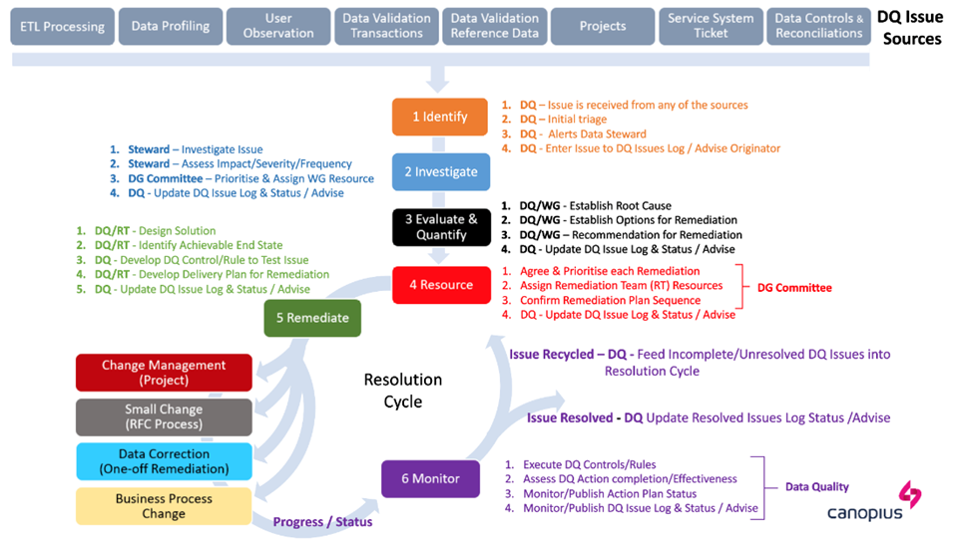
Figure 2: Data Quality Management Process Model

Control Model
The Control Model that underpins Data Governance consists of:

- The Group Data Policy that sets the principles - the “rules” which set the tone and direction of Data Governance and the standards which apply to data.
- Subject Policies that define in more detail the organisational requirements, the rationale, value, risk management and controls that apply in each area; and
- The Minimum Standards/ Procedures that define “what” is to be done to implement the Policy along with supporting guidelines which define “how” the standards are implemented.

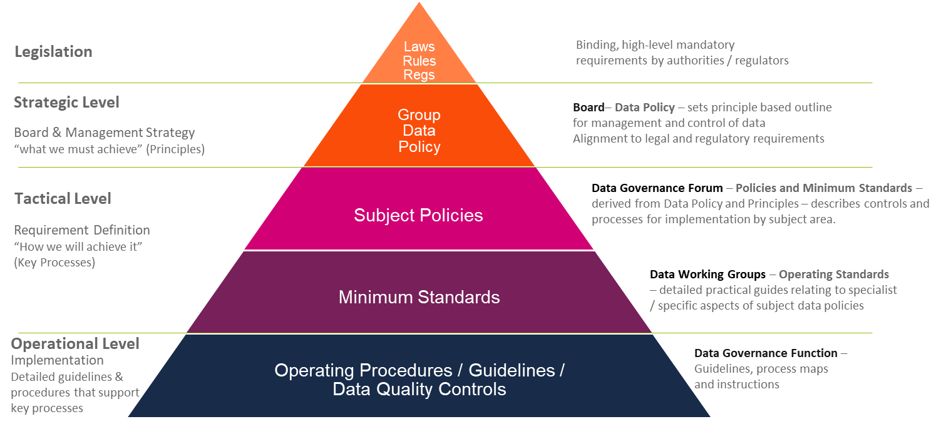
Figure 3: Data Governance Control Model

The control model is comprised of the Policy Framework (shown below), the processes that support the framework, the monitoring of compliance to it e.g. DQ run-time controls, and the alignment with change management.

Policies

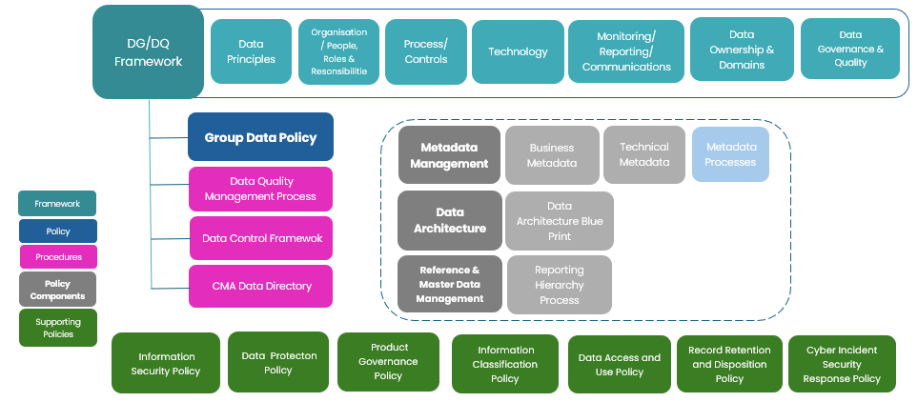

The Policy Framework consists of a number of policies with core policy being the Group Data Policy which set out the rules and standards for how we manage data in these core areas. There are a number of subject-specific policies and process documents that sit below and minimum standards, which document standard processes to ensure the desired outcomes.

A data control framework will be in place to capture key data controls and ensure compliance by the data owners to adhere to the Group Data Policy. The data control framework will document the data controls throughout the organisation and highlight key processes and controls during data handoffs.

The hierarchy between core policies, subject-specific policies and minimum standards is illustrated in Figure 4.

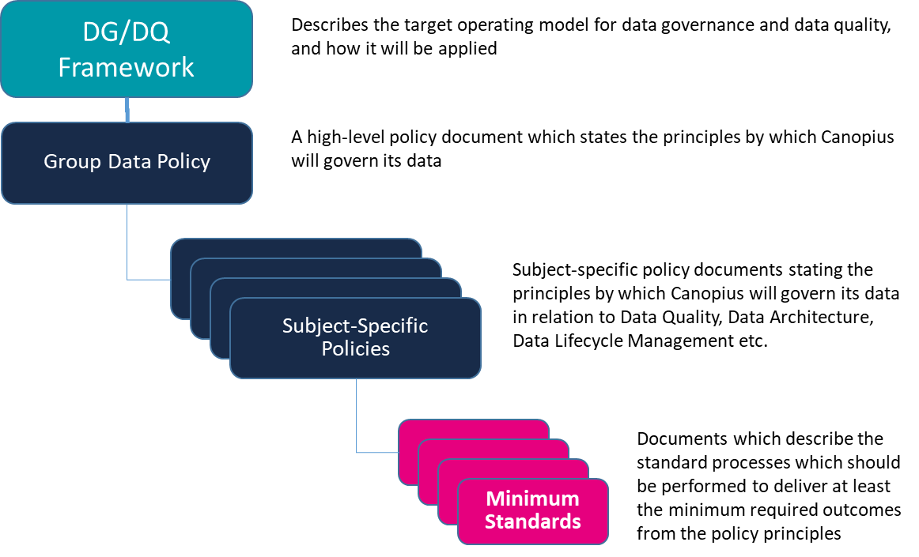
Figure 4; Framework, Policy, and Minimum Standards Model

Operational (Run-time) Data Quality Controls
A data quality control process reduces or eliminates the need for downstream users to monitor for poor-quality data.
Data Quality controls provide the ability to identify and document emerging data issues, then initiate a workflow to remediate these problems.
Operational data quality management combines the ability to identify data errors as early as possible with the process of initiating the activities necessary to address those errors and avoid or minimise any downstream impacts.
Data inspection processes, using data quality software such as DQPro, are instituted to measure and monitor compliance with data quality rules. Data quality inspection differs from data validation, which typically occurs when a record is initially created or updated.
The value of data quality inspection as part of operational data quality management is in establishing trust on behalf of downstream users that any issue likely to cause a significant business impact is caught early enough to avoid any significant impact on operations. Without this inspection process, poor-quality data pervades every system, complicating any operational or analytic process. A combination of methods, tools, and techniques are used as part of the process for instituting the inspection and monitoring necessary for observing the SLA:

- Metadata management: capturing information about data elements and their use.
- Data quality business rules using dimensions of data quality.
- Data profiling.
- Business intelligence tools as a way of reporting data issues within a prioritisation scheme.
- Incident management (incident reporting and tracking).

Technology
The Governance of Data is supported by a Data Governance or metadata management toolset that has the following minimum capabilities:
- Capture and storage of technical metadata describing the data structure, format, and its location – a Data Catalogue (including key attributes such as Personal, Key or Material data tags).
- The ability to develop a Glossary of Business Terms and add additional business metadata such as business rules and quality thresholds based on user driven values. These can be linked to the Data Catalogue.
- Data Lineage – visually describing the data journey including processing of data items from point of entry to consumption.
- Data Flows – visually describing the flow of data within the organisation / flow associated with a business process.
- Data Quality status of a given data item at any point in its journey.
- Capture of metadata associated with key business processes, MI / Business reporting.
- User access via an intuitive UI and ability to search against terms, internal and external data items, controls, owners, reports, domains etc.
- Workflow to manage maintenance and change.
The toolset meets the requirements of Data Quality Management Framework outside those already met by DQPro, which is at the core of the DQ Capability augmented by the Governance tools owned, managed, and operated by the DQM team to undertake data profiling, root cause analysis and capturing subsequent measurements of quality. The business rules and the data definitions against which profiling is undertaken are supported by DQPro and the Governance Tool, with generated metadata published to the Governance tool.

The illustration below describes the relationships between the components:
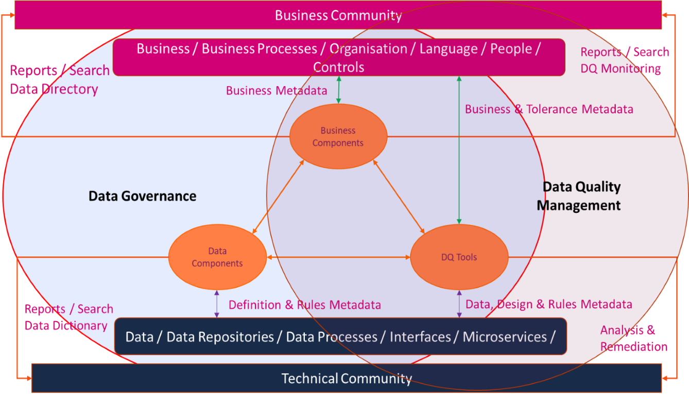

In addition to the Governance toolset, DQM requires metadata from across the data estate to monitor, measure and quality manage through controls, operational processes which generate local metadata.

Data Governance Technology Enablers
Supporting the DG Function are the following toolsets:
- Data Governance Toolset
- OneTrust
- ServiceNow
- DQ Pro toolset

Data Governance Toolset is owned and managed by the DG Function. It is used to catalogue data and build associations between data and other asset types (business processes, people etc.) to capture metadata about our data. It also provides capabilities to build and maintain technical data lineage for our data systems. It forms a key component of our data governance process, serving to both document information about our data and then allow business insight through tools such as lineage and glossaries.

DQ Pro is the data quality tool used by Canopius providing early warnings of data issues and control breaches before they become a problem. It is an essential data monitoring tool for Underwriters, however also used by Claims and Outwards RI teams. DQ Pro is owned and managed by DQT.

OneTrust is the toolset used to capture and manage PII (Personal Identifiable Information) data compliance and can capture and maintain PII related metadata. For example, OneTrust provides a simple and automated solution for data mapping, designed to address compliance with GDPR Article 30 record keeping requirements and self-certification with Privacy Shield for data transfers.

The Data Governance Function shall work closely with the DPO to ensure that the Data Governance toolset does not overlap with OneTrust, and equally where appropriate, the toolset is configured to support the DPO. OneTrust is owned by the Canopius Data Protection Officer.

ServiceNow is an IT service desk tool to report IT and data quality issues. These issues are then monitored and remediated by the DQT.

Data Quality Technology Enablers
Data profiling, inspection and monitoring are key DQ tool functionalities which are core to the DQ capability.

Data Profiling & Data Quality Scoring
Data profiling is a set of algorithms for statistically analysing and assessing the quality of data values within a data set, as well as exploring relationships that exist between data elements or across data sets. Data profiling provides the ability to identify data flaws as well to communicate these instances with subject matter experts whose business knowledge can confirm the existence of data problems. A data profiling tool will scan all the values in a column and provide a frequency distribution of that column’s values, suggesting the type and potential uses of each column. Cross-column analysis can expose embedded value dependencies, whereas inter-table analysis explores overlapping values sets to identify foreign key relationships between entities.

Data profiling can help discover business rules embedded within data sets, which can be used for ongoing inspection and monitoring. Data profiling along with other technology enablers can provide input into data scoring processes to ensure that the quality of information is made visible to end users.

Inspection and Monitoring
Because data profiling exposes potential business rules used within and across different business processes, the data quality analyst can document the rules and confirm their criticality in coordination with the data owners and/or business process owners. These rules describe the end-user data expectations and can be used to measure and monitor the validity of data. Inspection and monitoring of defined data quality rules provide a proactive assessment of compliance with expectations, and the results of these audits can feed data quality metrics populating management dashboards and scorecards.

At the core of the DQ Capability is the DQPro toolset augmented by the Governance tools owned, managed, and operated by the DQ Team to undertake data profiling, root cause analysis and capturing subsequent measurements of quality. The business rules and the data definitions against which profiling is undertaken are supported by DQPro and the Governance Tool.

Data Risks
The DG Function is responsible for the management of the capture, reporting and maintenance of detailed and specific data risks, as part of the organisation’s overall Risk Management process.

Data risk is the exposure to loss of value or reputation for Canopius, caused by issues or limitations to collect, acquire, store, archive, transform, process, share, purge and use its data assets. A lack of data risk management may expose Canopius to multiple risks, such as:

External faced risks:
- Non-compliance with regulatory or legal requirements
- Regulatory and Compliance Risk: e.g. Data privacy and protection (data breach) risks
- Inaccurate regulatory reporting
- Reputation issues
- Misuse of Canopius customer data by third parties
- Lack of customer trust (erroneous customer data)
- Unethical usage of data or their unreasonable usage

Internal risks
- Data security risks (Confidentiality, Integrity, Availability and Traceability)
- Incorrect decision making at strategic, tactical and/or operational level.
- Lack of Data Strategy and accountability (for ensuring data is correctly collected, acquired, stored, transformed, processed, shared, purged, archived, and used)
- Lack of data leadership, stewardship, culture, operating model, organisational structure, skills, and training
- Under-exploitation of business intelligence and analytics tools (to enhance decision making)
- Missing new value opportunities or costs savings (due to incorrect data-driven insights)
- Data acquisition risks
- Data quality risks (for all data quality dimensions)
- Lack of internal data trust or incorrect data interpretation
- Lacking competitive advantage
- Data misalignment or reporting inconsistencies.
- Data duplication and associated costs
- Lack of data architecture, data services, data interoperability and optimum data processing
- Lack in metadata-, master data- and reference data management.
- Lack of relevant data controls

To review and mitigate those risks, a risk management approach to Data Governance is proposed through the implementation of the Data Governance Framework.

The identification of data risks, and their capture within the data risk register, is undertaken primarily by Data Owners and Stewards under the direction of and with the support of the DG Function. The intention is for the detailed data risk register to mirror the Risk Register and be capable of contributing to it. It is the responsibility of the DG Function to gather these detailed data risks into a summary list and work with the Risk function to ensure that the systems are updated to mitigate such risks.

Monitoring

Data Governance Monitoring
The processes for monitoring Governance activity and effectiveness on a regular basis, and reporting to the DGF and Data Owners, are defined and established, along with defined KPIs.

Maturity and Effectiveness Models are established and run regularly to monitor progress on design and implementation and how it is embedding into the organisation to reach a level of operation where it becomes second nature to all data related activity. The scores are included in a Governance scorecard and targets set against over time.

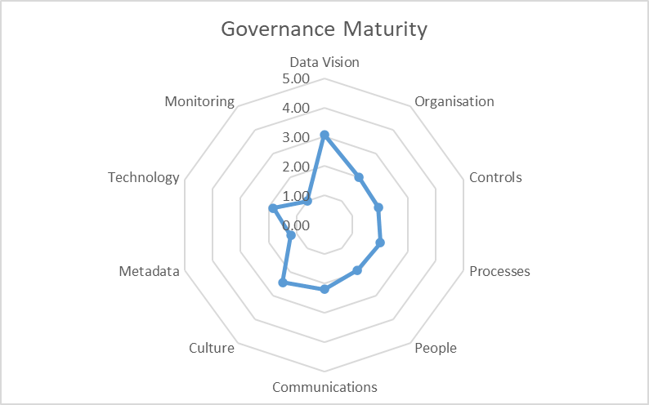
Figure 5: Example - Maturity Assessment

The overall Data Governance scorecard is empirical, and evidence based. Example metrics could include:

- A measure of the improvement in data quality.
- Compliance with data management standards and processes.
- The number of issues escalated to the Data Governance Forum.
- The number of issues escalated to the distinct Data Working Groups by the Business Data Owners and Data Stewards.
- The number of approved and implemented standards, rules, and processes.
- The integration of processes in a project’s lifecycle to ensure oversight of key data management initiatives.
- The number of business terms mapped to data catalogue assets.

Data Quality Monitoring
The processes for monitoring quality on a regular basis and reporting to the DGF and Data Owners, as well as supporting more operational quality management techniques such as DQPro SLAs, requires measuring conformance to business expectations and knowing when the appropriate Data Stewards need to be notified to remediate an issue. This requires both a method for quantifying conformance and the threshold for acceptability.

DQ Organisational Capabilities (incl. Policies and Standards):
- Capability KPIs: performance metrics for each of the DQ capabilities in place.
- Data Quality Scorecard: an aggregated view of data quality performance.

Reporting
The DG Function is responsible for establishing and maintaining the regular monitoring and reporting of Data Governance activity and effectiveness.

The DG Function is responsible for the production, publication, and maintenance of a scorecard. It develops the scorecard and more detailed reporting metrics that support it. In addition, the DG Function is responsible for supporting analysis, and where variances occur, identifying actions required and making recommendations to the relevant Governance bodies.

Communications
To support the implementation of the Framework and enable the achievement of a high quality, data led business, communication seeks to deliver a “no surprises” environment within Canopius in respect of Data Governance. To ensure this objective is met, the aim is to deliver communication to all those impacted or affected by any changes that subsequent activities implement, so they understand:
- The principles and organisation underpinning Data Governance and Quality Management.
- Why any changes are taking place and what the changes are.
- The impact of the changes on individuals and teams.
- What needs to be done.
- The support and resources available, and
- The process for escalation and reporting.

Audiences
- Data Owners
- Data Stewards
- Data Custodians
- Data Users
- Governance Functions / Practitioners
i.e. Those responsible for ensuring the organisational adherence to and application of all Regulatory and Legal requirements, Data Protection and Privacy, Data Security, Risk Management, Architectural Principles and Standards and the auditing thereof.

Communications Channels
The communication channels that are used include:
- Canopius Community Intranet for the Governance Resource Centre.
- The Data portal on the intranet, where data governance resources such as policies, forms, processes etc., are published for data users to access as needed.
- Formal meetings through the Governance Structures.
- Reports and presentations to the committees / working groups established under the Data Governance and Quality Management Frameworks.
- Meetings with allied Governance Functions.
- All Data Governance related resources are published to the allied Governance Functions (Risk, Compliance, InfoSec, etc.) as part of the review process, enabling maximum communication within the Governance Community.
- The Change Management function.
- Where change management processes are the facilitator for improved governance, changes to processes which are designing in Governance of Data will come through the Change Management Function.
- Training courses.
- Self-learning course material and face to face learning opportunities.

Change Management
The Data Governance Function will provide support as necessary to projects / change activity to assist them in understanding and ensuring compliance with the requirements of Data Governance.

Where a change / project activity takes place, the DG Function will be formally involved to:

- Ensure Data Governance is embedded by design.
- Ensure technical and business metadata are created or maintained.
- Ensure business rules for data quality are created/updated.
- Ensure Data Owners, Stewards, Custodians, Producers and Consumers are involved, informed, and kept updated.
- Ensure appropriate analysis is completed to assess downstream impact of any change on systems or user areas.

Appendix I - Definition of Terms
Data
Data is a means of representation, i.e., it stands for things other than itself. Data Items are an elementary and recorded description of things, events, activities, and transactions. Data represents unorganised and unprocessed facts, raw numbers, figures, symbols, images, words, or sounds, in both electronic and physical form. It is both an interpretation of the objects it represents and an object that must be interpreted.

NOTE: Data and Information are not interchangeable and synonymous terms. The scope and definition of Data and Information are different as are the principles that underpin their strategies, governance, and architectures. This Framework relates to Data only.
Information is formed of data taken in context with other data and is not constrained by the nature and format of the underlying data. Therefore, for example, a single claim amount is data, but a bar chart, showing total claim amount over time, is information.

Data Governance
The practice of supporting the business to maximise the return on data through the provision of people, processes, and technology to enable the implementation and operation of policies, procedures, and standards for the effective use of an organisation’s data assets.

Data governance is mostly about communication where people collaborate to establish data governance policies and processes that ensures that important data assets are formally managed throughout the enterprise and information about data is effectively captured, managed, and provisioned. Data governance ensures that data can be trusted, and that people can be made accountable for any adverse event that happens because of low data quality. It is a quality control discipline for assessing, managing, using, improving, monitoring, maintaining, and protecting organisational data and putting people in charge of fixing and preventing issues with data.

Data Quality
Data Quality is a measurement of the conditions that determine whether the data is fit for its intended use in a business process or operation. Therefore, data quality characterises:

- The degree to which given data objects satisfy the needs (fitness for purpose and use) of the business processes which consume the data i.e. in relation to the relevant data quality dimensions.
- In a broader sense, it refers to both the quality of data content as well as the performance of the underlying data management processes.
Improving data quality involves correcting defective data and implementing quality improvement procedures that ensure that the expected levels of data quality are achieved and maintained. The two principal subsets of data quality that are measured and reported by applying the principles and operating under the framework as articulated in this document, are the following:

- Data Definition and Data Architecture Quality
Data definition accurately describes the meaning of the real-world object or event that the data represent and meets the needs of the users to understand the data they use. Data design should correctly represent the structure of the inherent and real relationships of the data to represent real-world objects and events and is stable and flexible. Data definition and data design are the specification of the data product and must represent the views and needs of the business areas, applications, and end users of the data. Data definition and design includes the business definition, the domain or value set, and the business rules that govern the data.
- Data Content Quality
Data content quality cannot be measured without a quality definition. Data content quality is the degree to which the data values accurately represent the dimensions of the real-world object or event and meet the needs of the information end users to perform their jobs effectively.

Data Quality Management
Data Quality Management refers to both the characteristics associated with the data and to the processes used to measure or improve the quality of data. It is a necessary organisational capability to ensure compliance with GDPR, Lloyd’s Principles, Solvency II and IFRS 17. It also supports Canopius’ business operations by ensuring that any data entered, collected, used, recorded, and shared is accurate, complete, and reliable.

It also ensures that Canopius’ decisions are based upon reliable management and performance information and models, and provides confidence when benchmarking or producing reports, statistical analysis, and models for internal and external audiences.

Data Quality Management is a continuous process for defining, measuring, monitoring the parameters for acceptable levels of data quality to meet business needs, and remediating where quality levels fall short.

Data Quality Management Systems
Data Quality Management Systems (DQMS) is the combined capability of the people, processes, controls, and technology which is required to enable effective management and governance of data quality. Such processes are documented, implemented, and periodically reviewed within an organisation to monitor and support the DQMS and production of good quality data.

Data Quality Dimensions
See Appendix IV.

Policy
A policy document is a formal document containing definitions of the purpose, scope and responsibilities which must be acted upon or upheld for the defined purpose to be met. A policy document typically requires approval and sign-off from The Canopius Leadership Team (CLT).
Therefore, a data policy document sets out the “Rules” on appropriate and ethical use of data.

Minimum Standard
A Minimum Standard document is a formal document that is subordinate to a policy or policies, which describes the actions to be taken and the roles responsible for taking them to reach the specified policy outcome or a defined part of it.
This document describes “What” actions are required to comply with the rules defined in policy.

Data Domain
A Data Domain is a logical grouping of data to fulfil a specific business requirement for which the Data Owner is accountable. This grouping should be independent of business function, geography, or system.
The “Claims Data” domain includes all data specific to claims which is not owned within another domain e.g. Underwriting Data

Data Sub-Domain
Sub-domains divide the domain grouping of data into smaller and more specific components or sub-domains. A sub-domain is unique to one domain. A sub-domain typically has one or more subject matter experts (SMEs) who use their knowledge of that specific data to identify issues and maintain its “fitness for purpose.”

Dataset or Data Set
A dataset (or data set) is a grouping of data which is structured and scoped to fulfil a specific business requirement, which may be accessed individually or in combination or managed as a whole entity.
Datasets are specific collections of data which contain elements of the domain/sub-domains. A dataset could be an entire database, an individual file, or a spreadsheet. Datasets or parts of datasets are consumed as inputs or created as outputs by specific business processes which are the day-to-day focus of the sub-domain SMEs.

Data Owner
Data Owners are accountable for data within a specific Data Domain. They make decisions affecting data quality – e.g. business rules, quality levels/thresholds, and remediation prioritisation.
Collectively data owners review and sign-off the data governance control model components – e.g. policies and standards and individually attest to the level of quality of and compliance to the Policy Framework for the data within their data domain.

Data Steward
Is responsible for the day-to-day quality of the data within their respective data domains or sub-domains. Reporting to their respective Managing Data Owner, they are a member of one or more of the Data Working Groups which report into the Data Governance Forum.

Appendix II - Data Domains
The Canopius data domains, sub-domains, Accountable and Managing owner roles are summarised in the table below:

Business Function | Group Accountable Owner Role | Domain | Regional Scope | Managing Owner Role | Sub-Domain (indicative)
Underwriting | Group Chief Underwriting Officer | Policy Administration  (Underwriting) | London, APAC | Head of Underwriting Governance | Open Market Policy
 |  |  |  |  | Delegated Facilities
 |  |  |  |  | Conduct Data
Underwriting | Group Chief Underwriting Officer | Policy Administration  (Underwriting) | New York, Chicago, Bermuda | Chief Operations Officer | Open Market Policy
 |  |  |  |  | Delegated Facilities
Underwriting | Group Chief Underwriting Officer | Business Planning  (Underwriting) | Group Wide | Head of Portfolio Management  Head of FP&A | Business Planning
Underwriting | Group Chief Underwriting Officer | Policy Administration  (Outwards Reinsurance) | Group Wide | Head of Outward Reinsurance | Purchasing
 |  |  |  |  | Operations
Underwriting | Group Chief Underwriting Officer | Risk – Catastrophe Management | Group Wide | Global Head of Exposure Management | Catastrophe Management
Finance | Group Chief Financial Officer | Finance | UK | UK CFO | Syndicate
 |  |  |  |  | Lloyds Reporting
 |  |  |  | Director of Group Finance | Investments
 |  |  |  |  | Group
 |  |  |  | Head of Treasury | Treasury
Finance | Group Chief Financial Officer | Finance | CUSI, CUAI | US CFO | Finance US
Finance | Group Chief Financial Officer | Finance | Bermuda | CRe CFO | Finance CRe
Finance | Group Chief Financial Officer | Finance | APAC | CFO, APAC & MENA | Finance APAC
Actuarial | Group Chief Actuary | Actuarial Pricing | Group Wide | Group Head of Pricing | Pricing Data
 |  |  |  |  | Non-Pricing Data
Actuarial | Group Chief Actuary | Actuarial Reserving | Group Wide | UK Head of Actuarial | Syndicate & CRe Reserving
 |  |  |  |  | Technical Provisions/ IFRS
 |  |  |  |  | CUSI
Actuarial | Group Chief Actuary | Actuarial Capital | Group Wide | Group Head of Capital | Capital
Risk | Chief Risk & Governance Officer | Operational Risk  (Stress & Scenario) | Group Wide | UK Head of Risk | Operational Risk (Stress & Scenario)
Claims | Chief Claims Officer | Claims | Ownership Group Wide - Stewardship Regional | Head of Claims Operation | Claims Management
 |  |  |  |  | Delegated, TPA, Coverholders
 |  |  |  |  | APAC
 |  |  |  |  | CUSI
HR | Chief HR Officer | HR | Ownership Group Wide | Chief HR Officer | UK
 |  |  |  |  | APAC
 |  |  |  |  | US
Operations | Chief Operating Officer | Operations | Ownership Group Wide | Head of Group Operations | Complaints Data
Sustainability | Senior Sustainability Manager | Sustainability | Ownership Group Wide | Senior Sustainability Manager | Sustainability

Appendix III – Definition of Materiality
A number of materiality definitions exist and vary depending on the context of use but invariably reference the impact of information affecting decision making.
E.g. “Information is material if omitting it or misstating it could influence decisions that users make on the basis of financial information about a specific reporting entity.”
Financial Accounting Standards Board (FASB)
As material information is derived from data, then data has a direct impact on materiality.
The impact of material data can be:
- Financial
- Regulatory, or
- Business Process
With a view to understanding materiality in data terms within an insurance business context an additional definition can be applied:
- Any data item which is a component in the capital modelling process should be identified/classified as a “key” data item.
- When the value of a “key” data item exceeds a specified threshold then that instance of the “key” data item becomes “material.”

Management of Material Data
It follows that to manage materiality from a data perspective:
- Key data items are identified and their impact on materiality defined.
- The lineage of key items is traced from point of entry to point of use in the capital model. (Solvency II requirement)
- The quality of key data items is managed and regularly monitored.
- Priority is applied to the remediation of data quality issues affecting key data items.

Appendix IV: Dimensions of Data
Completeness
An expectation that certain attributes should have assigned values in a data field. Completeness rules can be assigned to identify mandatory, optional, or inapplicable attributes. For example, if a data is mandatory, a valid data item should be populated and there should be no blank / null fields. There can also be data items which are not mandatory in the target data set, but completeness is required to be maximised to support a given business process. Measures to monitor the acceptable level of completeness are defined to ensure that an agreed minimum level of completeness is maintained.

Completeness Statements
Data entry / collection processes should be clearly specified and matched to the information needs of the organisation.
Data should be complete and not contain redundant or duplicate records.
Missing, incomplete or invalid records must be monitored as they indicate potential recording problems or other issues impacting on data quality.

Uniqueness
No “entity” should exist more than once within a data set, so that there is only one instance of it appearing in a data set, thereby eliminating data duplication. For example, multiple instances of the same customer with different identifiers “IBM” and “I.B.M” and “International Business Machines.”

Uniqueness Statements
No record or attribute is recorded more than once in a specified set of data
Duplicate data should be matched and deduplicated

Consistent
Consistency is where there are data items which are related to other data items, and there are rules that define the relationship between them. A simple example of a consistency problem would be where a customer has no address details.

Another type of consistency is referential integrity and applies at an “entity” level in databases. This is typically where a data record requires a parent record to be present. For example, a policy “add-on” requires a parent Policy record.

Consistency Statements
Data entry processes must be clearly defined and followed to ensure on-going stability and consistency over time.
Where data consistency changes, such as with trend analysis data, then the trend data must reflect real change rather than variations in data entry/collection methods or approaches.
Data / Information must be from primary sources wherever possible.

Timeliness
The timeliness of data determines its value, decay, and operational significance. It refers to the revision of the data to identify when the data is updated and to identify any dependencies or delays with obtaining the most up to date data. The currency of the data refers to the degree to which it is up to date with the corresponding real-world entities.

The ability to measure through timestamping of data, and its adherence to retention and deletion schedules and policy is an important dimension to its quality.

Timeliness Statements
Data should be entered / collected as quickly as possible after the event, transaction, or activity, and must be available quickly enough to support downstream business needs and management decisions
Data will be available for the intended use within a reasonable or agreed time and quickly and frequently enough to support downstream business process, information, and decision needs.

Validity
Validity is defined by the rules in the system the data is stored in. This is typically a set of permitted values or a range of values that are permissible. For example, titles such as Mr, Mrs, Ms, Lord etc, Gender codes, age ranges, and telephone number formats.

Validity Statements
Data will be recorded and used in accordance with agreed business or statutory requirements, rules, and definitions to ensure principles.

Where 3rd Party or industry data is used this must satisfy the intended purpose of the data.

Accuracy
Data must be accurate with clear procedural guidance for collecting, using, and amending data. Accuracy is the degree with which those data values correctly reflect attributes of “real-life” entities e.g. post code data captured for a customer’s address is the correct post code as per the Royal Mail.

Accuracy Statements
Data will be sufficiently accurate for its intended purpose and provide a clear representation of the activity / interaction and performance.
Data will be captured once only and as close to the point of activity as possible.
Data will be checked at the point of entry / collection wherever possible.
Data will be in sufficient detail for its intended purpose
The costs and effort of entry / collection will be balanced with the importance of the data, timeliness requirements and the need for accuracy.
Where compromises have been made to accuracy for valid business reasons, for example where some data is estimated, this must be made clear to data users.

Standards Based (or Conformity)
Data must conform to the data standards set for the data item(s) in scope, and is a measurement of the alignment of content to the required standards which can be internal, external or industry wide, for example; Invalid ISO currency codes, violation of allowable values (i.e. state code for a country that doesn’t have states) or Inconsistent date formats (mix of US / UK formats).

Standards / Conformity Statements
Data will conform to standards defined within the data design.
Data will conform to external or industry standards where applicable e.g. ISO Codes.
Data will be consistent in its conformity e.g. Date Formats.

The characteristics defined above apply to all data. However specific additional characteristics will need to be identified and applied to specific data types or use, for example, data in web documents can also include accessibility, credibility, involvement, objectivity, readability, relevance, style, and usefulness as additional characteristics against which quality can be measured.

Data Working Groups
Operations Management Forum
Group COO
Data Governance Forum
GLT
(GCEO)
Group Leadership Team

